Name _________________________________________________
DYS ‘20
All Grades Thank You Card Activity

For your final Art assignment, I would like for you to make a “Thank You” card for your teachers. Show them just how much you appreciate them for their continued efforts to teach in this challenging time. Don’t forget to write your teacher’s name and sign your name on your card. Please bring your cards with you to school on your assigned day to pick up your personal items (see the schedule below). Have fun
Materials: cardstock paper or construction paper (if you have it) pencil, crayons, markers or colored pencils.
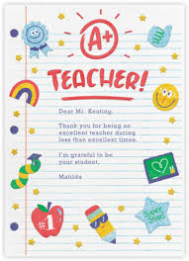
Pick-up / Drop-off Schedule
- Wednesday 5/13/20
K 8:00am-11:00am
1st 1:00pm – 4:00pm
- Thursday 5/14/20
2nd 8:00am-11:00am
3rd 1:00pm – 4:00pm
- Friday 5/15/20
4th 8:00am-11:00am
5th 1:00pm – 4:00pm

These are samples if you do not have
Ideas of your own. I prefer you do your OWN designs.

