Name _________________________________________________
DYS ‘20
Grade 5 - I Think… I See… I Wonder…

Closely study the clay sculpture below. Write a response in the space provided expounding on what you Think…. See…. and Wonder.
Yuanxing Liang
I think ______________________________________
_____________________________________________________
____________________________________________________________________________________________________________________________________________________________________________________________________________________
I see ____ _______________________________________
_____________________________________________________
_________________________________________________________________________________________________________________________________________________________________________________________________________________________________________________________________________
I wonder ___________________________ _____________________________________________________
_____________________________________________________
_______________________________________________________________________________________________________________________________________________________________

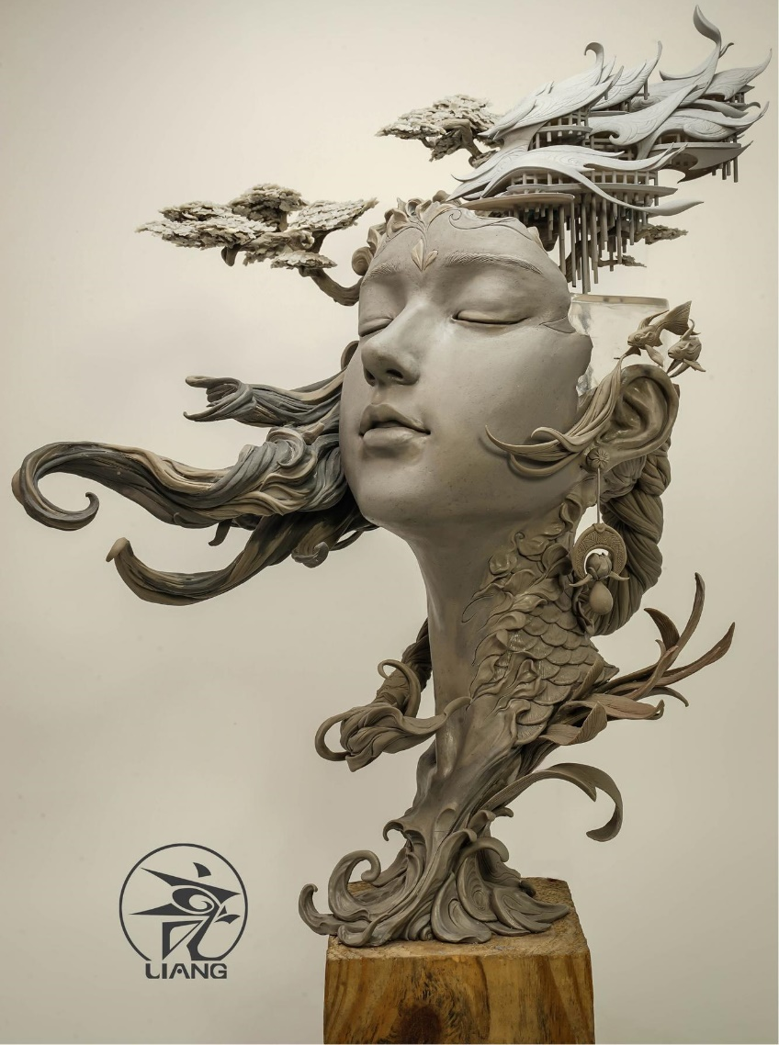
Name _________________________________________________
DYS ‘20
Grade 4 - I Think… I See… I Wonder…

Closely study the sculpted piece below. Write a response in the space provided expounding on what you Think…. See…. and Wonder.
Sylvia Shaw, “Bird Girl” 1936
I think ______________________________________
_____________________________________________________
____________________________________________________________________________________________________________________________________________________________________________________________________________________
I see ____ _______________________________________
_____________________________________________________
_________________________________________________________________________________________________________________________________________________________________________________________________________________________________________________________________________
I wonder ___________________________ _____________________________________________________
_____________________________________________________
_______________________________________________________________________________________________________________________________________________________________

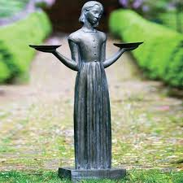
Name _________________________________________________
DYS ‘20
Grade 3 - I Think… I See… I Wonder…

Closely study the clay sculpture below. Write a response in the space provided expounding on what you Think…. See…. and Wonder.
I think ______________________________________
_____________________________________________________
____________________________________________________________________________________________________________________________________________________________________________________________________________________
I see ____ _______________________________________
_____________________________________________________
_________________________________________________________________________________________________________________________________________________________________________________________________________________________________________________________________________
I wonder ___________________________ _____________________________________________________
_____________________________________________________
_______________________________________________________________________________________________________________________________________________________________

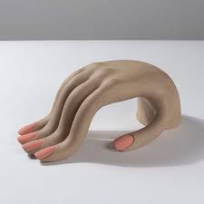
Genesis Belanger, Acquiescence (bent hand), 2018
Name _________________________________________________
DYS ‘20
Grade 2 - I Think… I See… I Wonder…

Closely study the art piece below. Write a response in the space provided explaining what you Think…. See…. and Wonder.
Painting of Uluru by Danny Eastwood
I think ______________________________________
_____________________________________________________
____________________________________________________________________________________________________________________________________________________________________________________________________________________
I see ____ _______________________________________
_____________________________________________________
_________________________________________________________________________________________________________________________________________________________________________________________________________________________________________________________________________
I wonder ___________________________ _____________________________________________________
_____________________________________________________
_______________________________________________________________________________________________________________________________________________________________

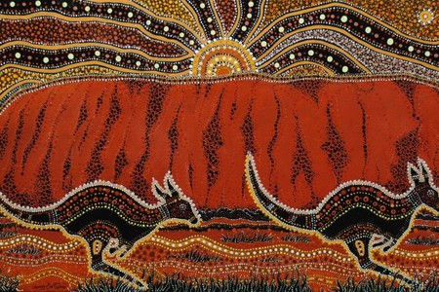
Name _________________________________________________
DYS ‘20
Grade 1 - I Think… I See… I Wonder…

Closely study the art piece below. Write a response in the space provided explaining what you Think…. See…. and Wonder.
I think ______________________________________
_____________________________________________________
____________________________________________________________________________________________________________________________________________________________________________________________________________________
I see ____ _______________________________________
_____________________________________________________
_________________________________________________________________________________________________________________________________________________________________________________________________________________________________________________________________________
I wonder ___________________________ _____________________________________________________
_____________________________________________________
_______________________________________________________________________________________________________________________________________________________________

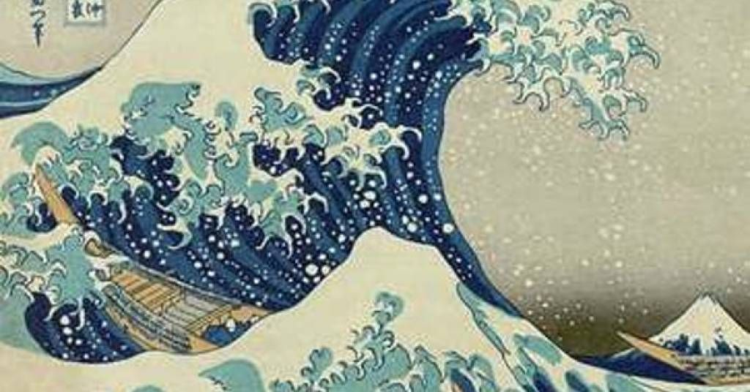
Katsushika Hokusai The Underwave off Kanagawa, 1829/183
Name _________________________________________________
DYS ‘20
Grade K - Shapes, Shapes and More Shapes

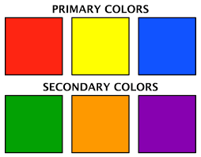
Use the color key to color all the shapes in the picture below.

