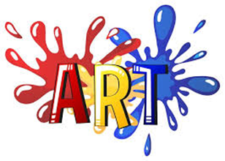
Name _________________________________________________
DYS ‘20
All Grades Drawing Practice Activity

This week, I would like for you to make a “Color Wheel” out of found items. It’s easy. Simply collect items that are Primary and Secondary colors and arrange them in a circle (see the samples below). Take a picture of your color wheel, print it and add it to your art portfolio. Have fun
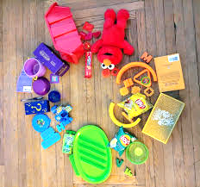
Color Wheel
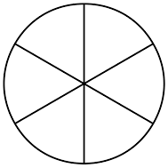
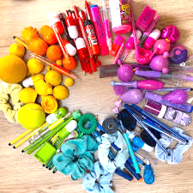
Color the wheel. Start with
your Primary Colors then do
your Secondary Colors.

p
p
s
s
s
p

