Name _________________________________________________
DYS ‘20
All Grades Drawing Practice Activity

This week, I would like for you to try “Shadow Drawing”. It’s easy. Simply wait for a sunny day, gather some items, paper and a pencil. Position your items in front of the paper to cast a shadow on the paper. Trace the shadow of your images. Color or fill with different line patterns. Have fun
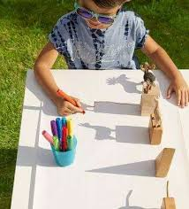
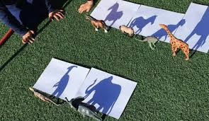
Materials:
Paper Pencil Toys
Sample pictures:

